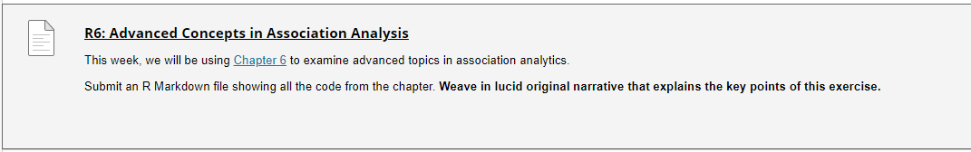

Chapter 6: <https://mhahsler.github.io/Introduction_to_Data_Mining_R_Examples/book/association-analysis-advanced-concepts.html#association-analysis-advanced-concepts>

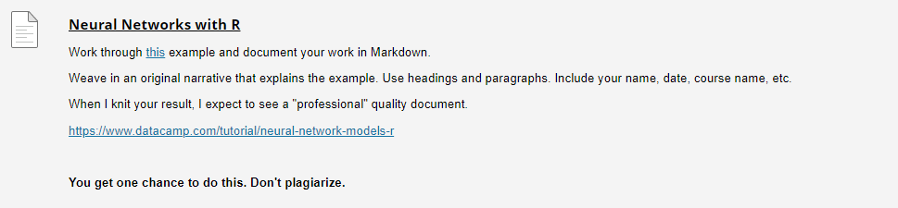

This example: <https://www.datacamp.com/tutorial/neural-network-models-r>

<https://www.datacamp.com/tutorial/neural-network-models-r>